Python Script

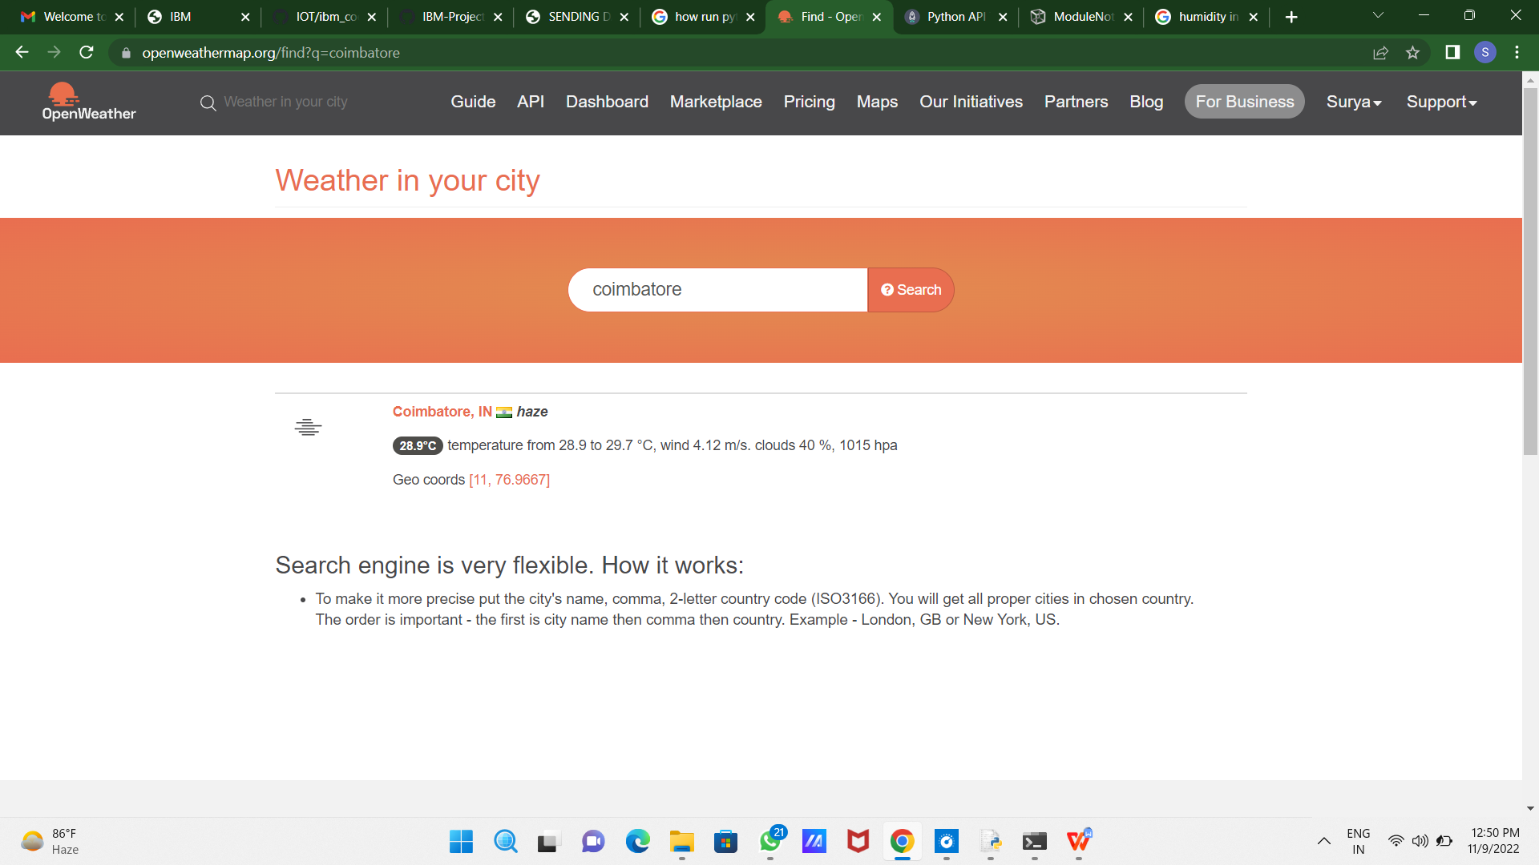

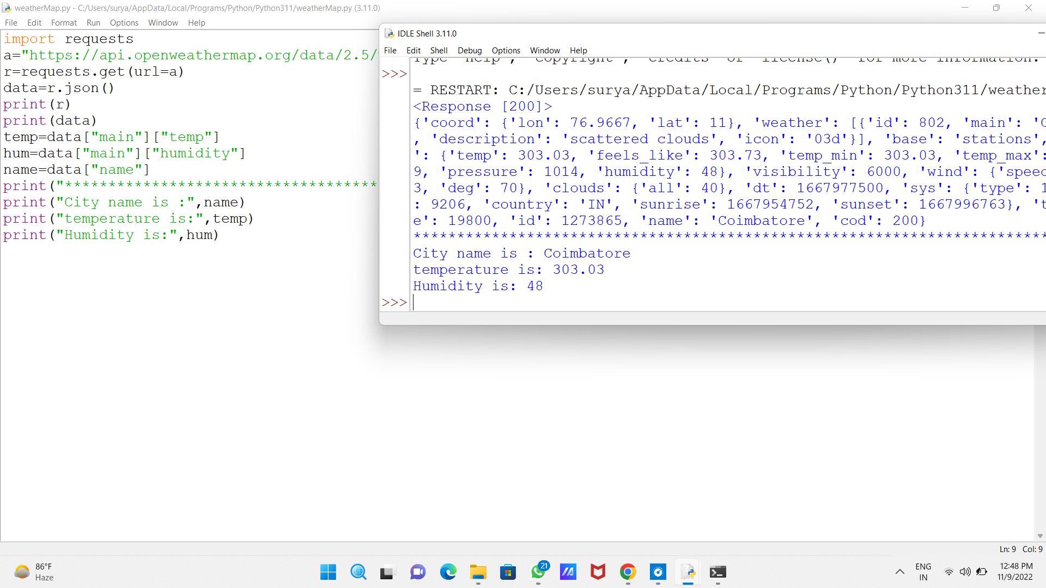

import requests

a="https://api.openweathermap.org/data/2.5/weather?q=coimbatore,IN&appid=6d13d12f9cd34a07871a5795d01e2c47"

r=requests.get(url=a)

data=r.json()

print(r)

print(data)

temp=data["main"]["temp"]

hum=data["main"]["humidity"]

name=data["name"]

print("\*\*\*\*\*\*\*\*\*\*\*\*\*\*\*\*\*\*\*\*\*\*\*\*\*\*\*\*\*\*\*\*\*\*\*\*\*\*\*\*\*\*\*\*\*\*\*\*\*\*\*\*\*\*\*\*\*\*\*\*\*\*\*\*\*\*\*\*\*\*\*\*\*\*\*\*\*\*")

print("City name is :",name)

print("temperature is:",temp)

print("Humidity is:",hum)